Module (JAVASCRIPT BASIC & DOM) – 4

Q.1 What is JavaScript. How to use it?

JavaScript is the Programming Language for the Web. JavaScript can update and change both HTML and CSS. JavaScript can calculate, manipulate, and validate data.

JavaScript is the most powerful and versatile web programming language. It is used for making the websites interactive. JavaScript helps us add features like animations, interactive forms, and dynamic content to web pages. In this JavaScript Tutorial, we learn all the basics to advanced topics and concepts of JavaScript.

Q.2 How many types of Variables in JavaScript?

There are mainly three types.

Automatically

Let

Var

const

Let: let is block-scoped, meaning it is limited to the block, statement, or expression where it is used.

You cannot re-declare a let variable within the same block scope.

Var: var is function-scoped, meaning it is limited to the function within which it is declared. If declared outside any function, it becomes globally scoped.

You can re-declare a var variable within the same scope.

Const: const is block-scoped like let.

const is hoisted to the top of its block, but not initialized, also leading to temporal dead zone.

Q.3 Define a Data Types in js?

data types are categories of values that determine how the data can be used and manipulated within the program. JavaScript is a dynamically typed language, meaning variables do not need to be declared with a specific type, and types are determined at runtime.

There are mainly two types of data types

Primitive

Non-primitive

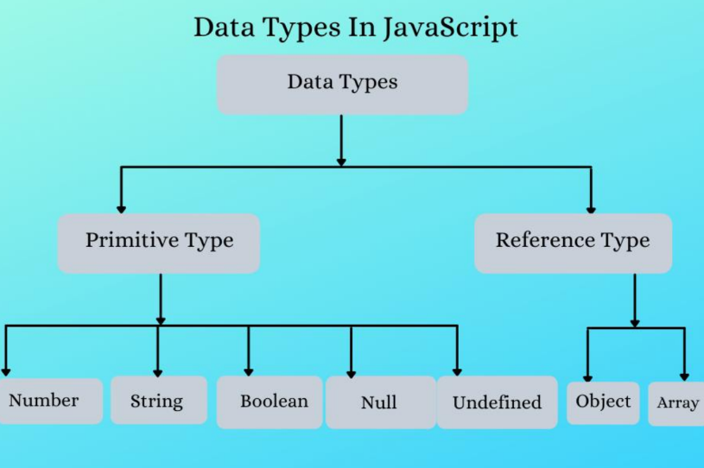

Q.5 What the deference between undefined and undeclare in JavaScript?

Undeclare: These are the variables that do not exist in the memory heap.

The variables are considered to be undeclared because of programmer does not write them with var, let, or const.

If we try to access them in the code execution phase then javascript will throw a Reference error.

Undefined: These variables are the ones that do exist in memory but nothing is being assigned to them explicitly by the programmer.

The variables are considered to be undefined because it is assigned by javascript to them.

If we try to access these variables, we will get the undefined as value.

Q.6 Using console.log () print out the following statement: The quote 'There is no exercise better for the heart than reaching down and lifting people up.' by John Holmes teaches us to help one another. Using console.log () print out the following quote by Mother Teresa:



Q.9 Write a JavaScript program to calculate days left until next Christmas?

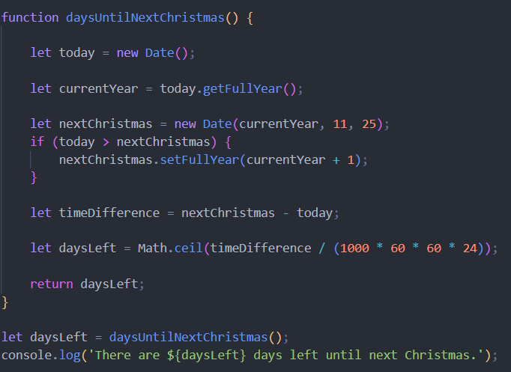

Q.10 What is Condition Statement?

A conditional statement in JavaScript is a control structure that allows you to execute certain blocks of code based on whether a specified condition is true or false. Conditional statements are fundamental in programming as they enable you to make decisions and execute different code paths based on those decisions.

If (condition is true)

Else (condition is false)

Else if (if the first condition is false)

Switch case

If:

if (condition) {

}

Else:

if (condition) {

if the condition is true

} else {

if the condition is false

}

Else if statement:

if (condition1) {

if condition1 is true

} else if (condition2) {

if the condition1 is false and condition2 is true

} else {

if the condition1 is false and condition2 is false

}

Q.15 What is the result of the expression (5 > 3 && 2 < 4)?

5 > 3 evaluates to ‘true’

2 < 4 evaluates to ‘true’

Since both operands are true, the logical AND operation returns true.

Therefore, the result of the expression is true.

Q.16 What is the result of the expression (true && 1 && "hello")?

the result of the expression (true && 1 && "hello") is "hello".

Q.17 What is the result of the expression true && false || false && true?

the result of the expression true && false || false && true is false.

Q.18 What is a Loop and Switch Case in JavaScript define that?

Loops are control structures that allow you to execute a block of code repeatedly until a specified condition is met. JavaScript supports several types of loops:

For loop

While loop

do…while loop

The switch statement evaluates an expression and executes a block of code depending on the value of the expression. It is often used as an alternative to long if...else if...else chains when you have multiple conditions to check.

Q.19 What is the use of is Nan function?

**Nan ()**Function is used to check whether a given value is an illegal number or not. It returns true if the value is a NaN else returns false. It is different from the Number.isNaN() Method.

Q.20 What is the difference between && and || in JavaScript?

&&

The && operator returns true if both operands are true.

It returns false if at least one of the operands is false.

T & F / F

F & T / F

T & T / T

F & F / F

||

The || operator returns true if at least one of the operands is true.

It returns false if both operands are false.

T || F / T

F || T / T

T || T / T

F || F / F

Q.22 Check Number Is Positive or Negative in JavaScript?

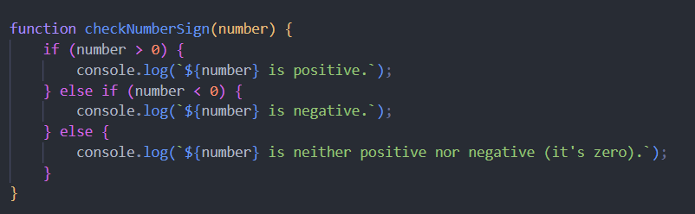

Q.23 Find the Character Is Vowel or Not?

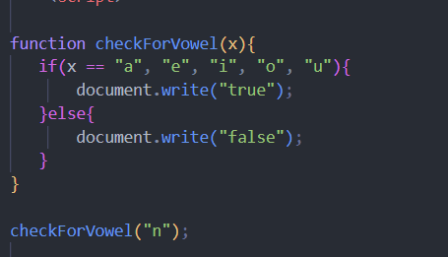

Q.24 Write to check whether a number is negative, positive or zero?

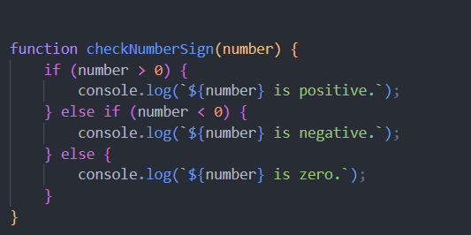

Q.26 Write find maximum number among 3 numbers using ternary operator in JS?

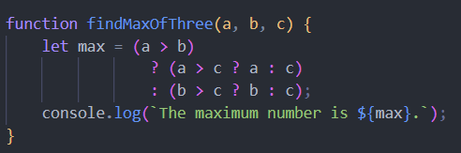

Q.28 Write to find the largest of three numbers in JS?

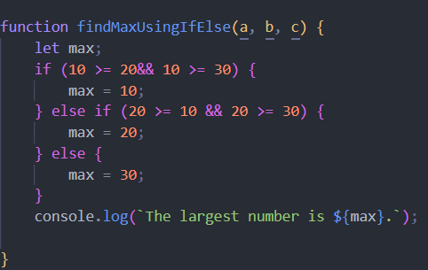

Q.29 Write to show

i. Monday to Sunday using switch case in JS?

ii. Vowel or Consonant using switch case in JS?

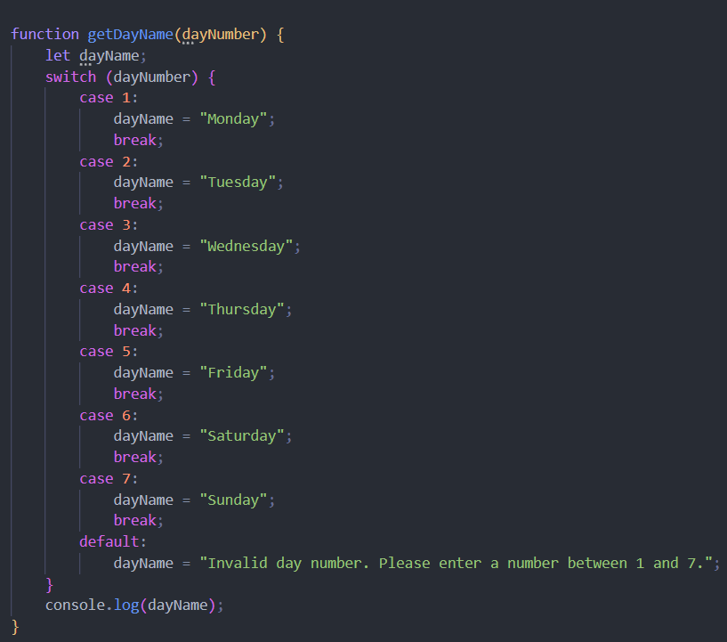

Q.30 What are the looping structures in JavaScript? Any one Example?

JavaScript loops are essential for efficiently handling repetitive tasks. They execute a block of code repeatedly as long as a specified condition remains true. These loops are powerful tools for automating tasks and streamlining your code. For example, suppose we want to print “Hello World” 5 times. This can be done using JS Loop easily.

• What is JavaScript?

JavaScript is a versatile, high-level, interpreted programming language primarily known for adding interactive and dynamic elements to web pages. It is an essential component of web development, alongside HTML and CSS.

• What is the use of isNaN function?

The isNaN function in JavaScript is used to determine whether a value is "Not-a-Number" . NaN is a special value in JavaScript that represents a value that is not a legal number.

• What is negative Infinity?

-Infinity (negative infinity) are special numeric values that represent positive and negative infinity, respectively. These values are used to denote values that are beyond the limits of the largest or smallest possible numbers representable in JavaScript.

• Which company developed JavaScript?

JavaScript was developed by Netscape Communications Corporation. Specifically, it was created by Brendan Eich while he was working at Netscape. The language was first released in 1995, initially under the name "Mocha," then it was renamed to "LiveScript," and finally, it was renamed "JavaScript" to reflect Netscape's support of Java within its browser.

• What are undeclared and undefined variables?

In JavaScript, undeclared and undefined variables are two different concepts that often confuse beginners. Let's break down each term and understand the differences between them:

**Undeclared Variables**

**Undeclared Variables**: These are variables that have not been declared using the var, let, or const keyword before being used. Accessing an undeclared variable typically results in a Reference Error.

**Undefined Variables**

**Undefined Variables**: These are variables that have been declared but have not been assigned a value. The default value of such variables is undefined.

• What is === operator?

In JavaScript, the === operator is known as the "strict equality" operator. It is used to compare two values for equality without performing type conversion. This means that both the value and the type of the operands must be the same for the comparison to return true.

• How can the style/class of an element be changed?

**Changing the Style**

**Inline Style Changes**

You can directly modify the style property of an element to change its inline styles.

**CSS Style Object**

You can also set multiple styles at once using the style object.

**Changing the Class**

**Using className**

You can set the className property to change the class of an element.

• How to read and write a file using JavaScript?

**Reading a File**

To read a file in a browser, you can use the FileReader API. This allows you to read the contents of files selected by the user through an <input type="file"> element.

**Writing to a File**

In a browser, direct writing to files is generally not allowed due to security constraints. However, you can generate files and prompt the user to download them. This can be done using the Blob and APIs.

• What are all the looping structures in JavaScript?

Loops are handy, if you want to run the same code over and over again, each time with a different value.

JavaScript supports different kinds of loops:

for - loops through a block of code a number of times

for/in - loops through the properties of an object

for/of - loops through the values of an iterable object

while - loops through a block of code while a specified condition is true

do/while - also loops through a block of code while a specified condition is true

• How can you convert the string of any base to an integer in JavaScript?

In JavaScript, you can convert a string of any base to an integer using the parseInt function. The parseInt function takes two arguments: the string to be converted and the radix (base) of the number system. The radix is an integer between 2 and 36 that represents the base of the numeral system.

• What is the function of the delete operator?

The delete operator in JavaScript is used to remove a property from an object. If the property is successfully deleted, delete returns true; otherwise, it returns false.

• What are all the types of Pop-up boxes available in JavaScript?

In JavaScript, there are three primary types of popup boxes that you can use to interact with users. These popup boxes are built into the browser and can be used for various purposes like displaying messages, getting user input, or confirming actions.

• What is the use of Void (0)?

the void operator is used to evaluate an expression and return undefined. One of the common uses of void is in conjunction with 0 to prevent the default behavior of an element, such as a hyperlink, without navigating away from the current page.

• How can a page be forced to load another page in JavaScript?

In JavaScript, you can force a web page to load another page using various methods. The most common way to do this is by manipulating the window. location object, which contains information about the current URL and allows you to change the URL, thereby navigating to another page.

• What are the disadvantages of using innerHTML in JavaScript?

The use of innerHTML very slow: The process of using innerHTML is much slower as its contents as slowly built, also already parsed contents and elements are also re-parsed which takes time.

Preserves event handlers attached to any DOM elements: The event handlers do not get attached to the new elements created by setting innerHTML automatically. To do so one has to keep track of the event handlers and attach it to new elements manually. This may cause a memory leak on some browsers.

Content is replaced everywhere: Either you add, append, delete, or modify contents on a webpage using innerHTML, all contents is replaced, also all the DOM nodes inside that element are reparsed and recreated.

Appending to innerHTML is not supported: Usually, += is used for appending in JavaScript. But on appending to an Html tag using innerHTML, the whole tag is re-parsed.

• Create password field with show hide functionalities.

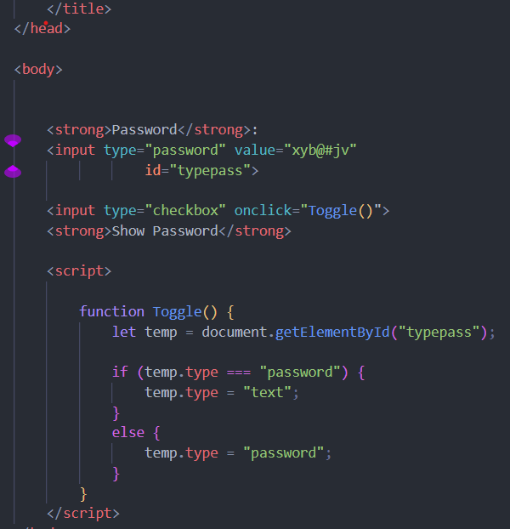

• Create result

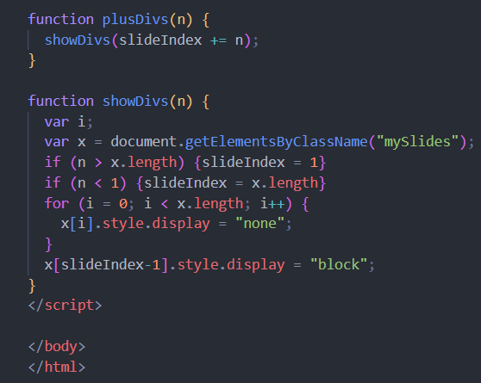

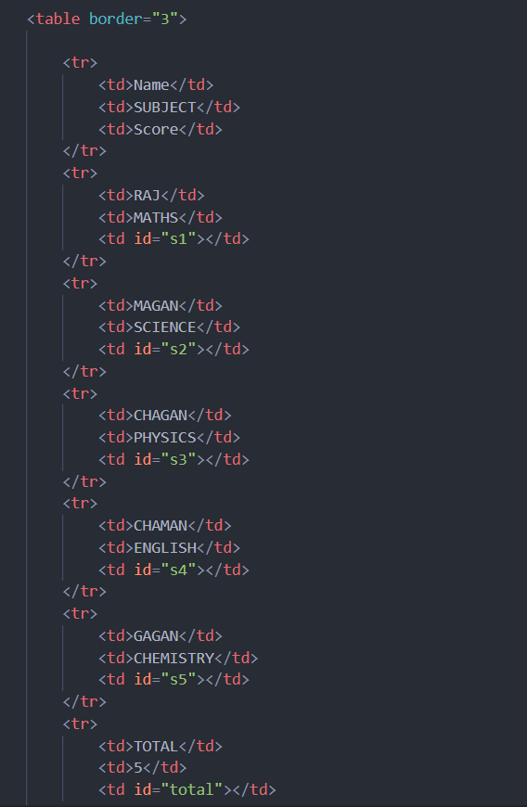

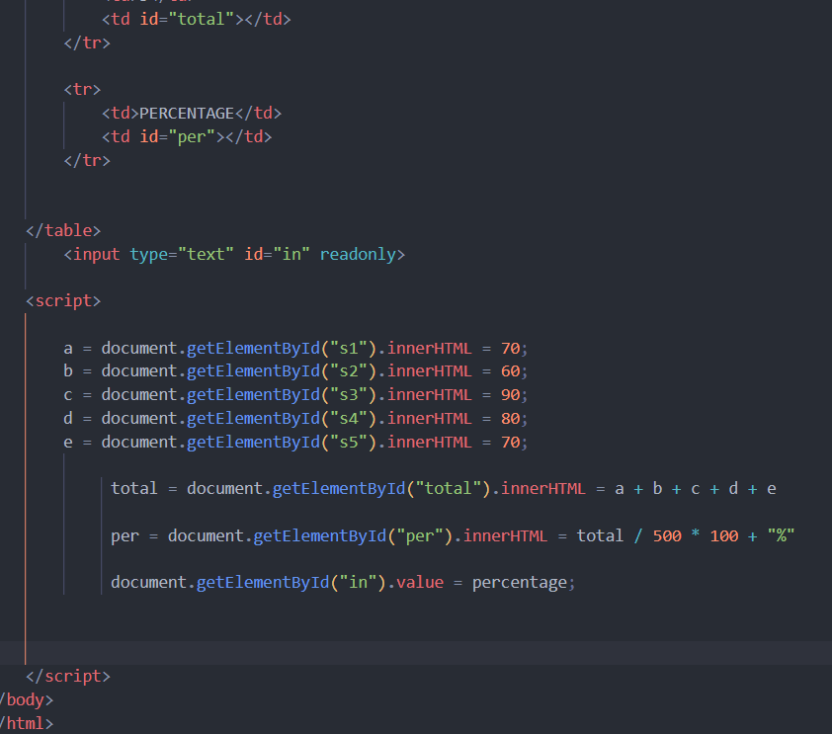

• Create basic math operation in JS

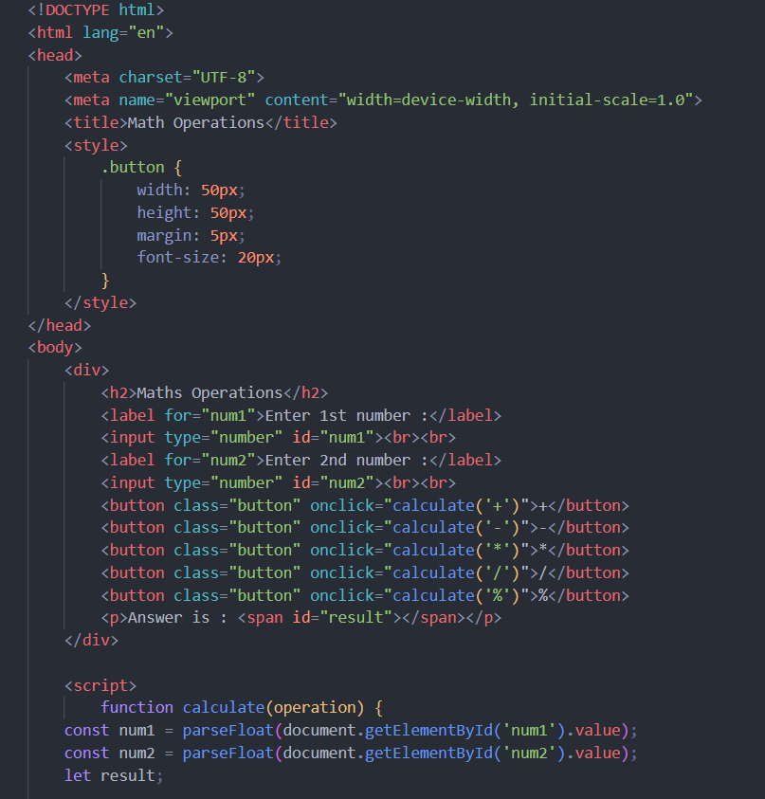

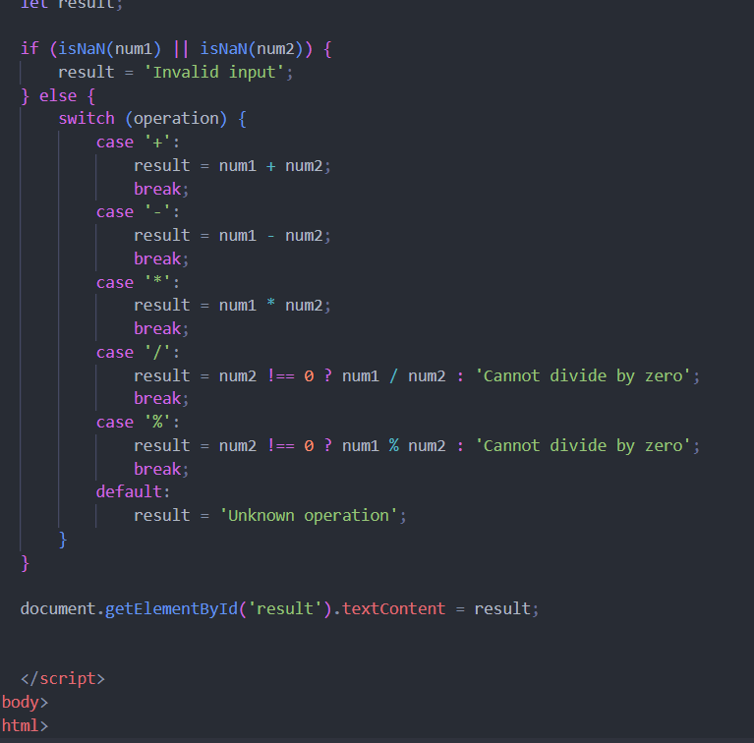

• Create a slider using JavaScript

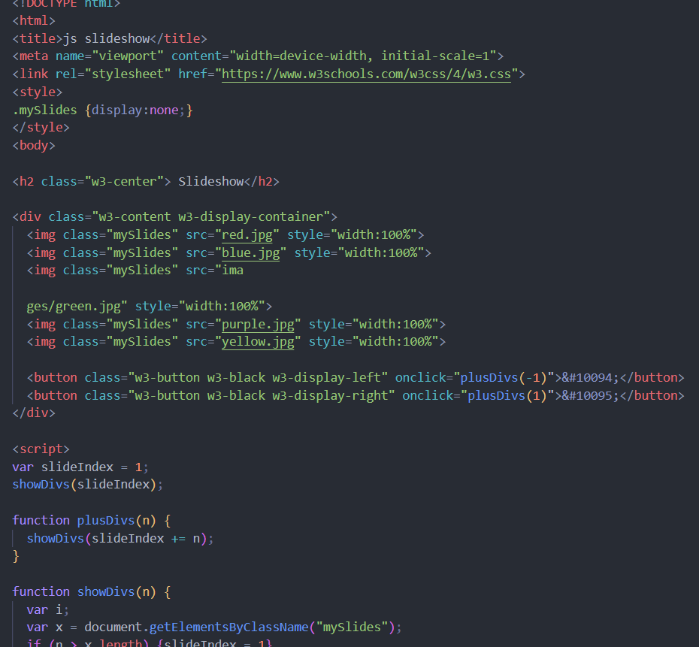



• What is JavaScript?

JavaScript is a high-level, interpreted programming language that is widely used to create dynamic and interactive effects within web browsers.

• What is the use of isNaN function?

Nan () Function is used to check whether a given value is an illegal number or not. It returns true if the value is a NaN else returns false. It is different from the Number.isNaN() Method.

• What is negative Infinity?

Negative Infinity in JavaScript is a special value that represents a value that is less than any other number. It is a property of the global Number object and can be used in mathematical operations.

• Which company developed JavaScript?

JavaScript was developed by Netscape Communications Corporation.

• What are undeclared and undefined variables?

Undeclared Variables

Undeclared variables are those that have not been declared in the current scope using var, let, or const. If you try to access an undeclared variable, JavaScript will throw a ReferenceError.

Undefined Variables

Undefined variables are those that have been declared but not assigned a value. In JavaScript, if a variable is declared but not initialized, it is automatically assigned the value undefined.

• Write the code for adding new elements dynamically?

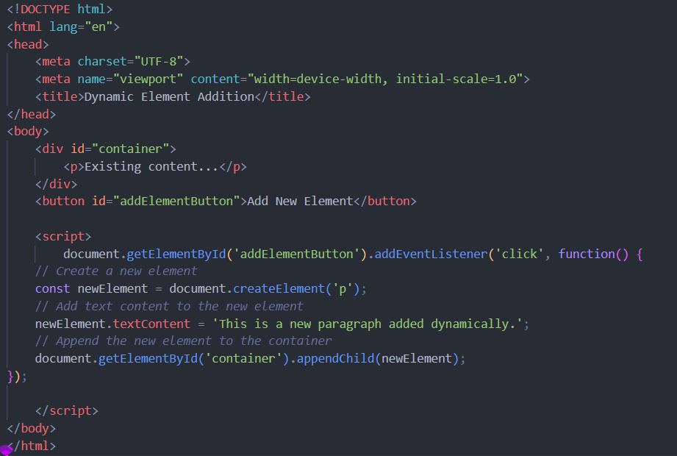

• What is the difference between ViewState and SessionState?

ViewState is a client-side state management technique that stores data for the duration of a single page's lifecycle, typically using hidden fields within the page. SessionState, on the other hand, is a server-side mechanism that stores user-specific data across multiple pages for the duration of a user's session.

• What is === operator?

The === operator in JavaScript is known as the strict equality operator. It checks whether two values are equal in both value and type without performing type conversion.

• How can the style/class of an element be changed?

The style or class of an element in a web page can be changed using JavaScript.

Changing the Style of an Element

You can directly manipulate the inline styles of an element using the style property in JavaScript.

Changing the Class of an Element

To change the class of an element, you can use the className or classList properties.

• How to read and write a file using JavaScript?

Reading and writing files using JavaScript typically involves working with the File and FileReader objects for reading files, and the File and Blob objects along with the FileWriter or FileOutputStream for writing files.

• What are all the looping structures in JavaScript?

In JavaScript, there are several looping structures that allow you to execute a block of code repeatedly as long as a condition is true or iterate over elements in a collection.

• How can you convert the string of any base to an integer in JavaScript?

In JavaScript, you can convert a string representing a number in any base to an integer using the parseInt function. The parseInt function takes two arguments: the string to be converted and the base of the number system used in the string.

• What is the function of the delete operator?

The delete operator in JavaScript is used to remove a property from an object. When a property is deleted using the delete operator, it is removed from the object, and attempting to access it afterwards will return undefined.

• What are all the types of Pop- up boxes available in JavaScript?

In JavaScript, there are three main types of pop-up boxes that you can use to interact with users:

Alert Box

Confirm Box

Prompt Box

• What is the use of Void (0)?

void (0) in JavaScript is used to prevent the default action of a hyperlink, ensuring it does not navigate or reload the page. It is often used in the href attribute of <a> tags to make the link trigger JavaScript without changing the current page.

• How can a page be forced to load another page in JavaScript?

In JavaScript, you can force a page to load another page by setting the window. Location property or using the window. location. replace () method.

• What are the disadvantages of using inner HTML in JavaScript?

Using inner HTML in JavaScript can introduce security risks like XSS vulnerabilities, cause performance issues due to complete re-rendering, remove event handlers on child elements, and lead to malformed HTML if not well-formed. It is often better to use safer alternatives like text Content or DOM manipulation methods.